**Kinematics and Balancing of Humanoid**

**Submitted to:** Dr. Abhishek Sarkar, Senior Research Scientist, IIIT Hyderabad

**Submitted By:** Diwakar Vaish and Nishanth. B, Winter Intern @IIITH,

B.Tech ME Student @ PDPM IIIT DM Jabalpur.

**Date:** 28, Dec, 2016

**Place:** Hyderabad

**Acknowledgement**

We would like to thank Dr. Abhishek Sarkar, Senior Research Scientist, Robotics Research Center, IIIT Hyderabad for giving us the opportunity and allowing us to work on the Humanoid Project. It was a great experience working under you Sir. Your way of Step by Step Guiding was very effective in letting me learn about Manipulators and applying it to the Humanoid.

Also we would like to thank Phani Singamaneni MS Student IIIT Hyderabad, who is doing thesis on Humanoid, who helped us a lot in clearing our doubt and guiding us frankly like a friend.

**Introduction**

We started learning about manipulator kinematics from the Book [Introduction to Robotics, 3e - John J Craig], then we followed [Robot Dynamics and Control Second Edition Mark W. Spong, Seth Hutchinson, and M. Vidyasagar]. We learnt about the Transformation for serial link manipulator. Then we learned DH Parameter for Kinematic Link.

Then using DH Parameter we moved on to Forward Kinematics. From Forward Kinematic Equation we derived the Inverse Kinematics Equation.

While solving Inverse Kinematic Equation we learnt about the Singularity and Redundancy and ways to overcome them so as to solve the Inverse Kinematics Equation.

We have learnt the Jacobian which is used to solve velocity kinematics of the humanoid. Also applied limits to the Joints as constraints.

Learnt Forward Dynamics using Jacobian for serial link manipulator and applied it for humanoid moment calculation.

**Application**

* Applied DH parameter to Simple Serial Manipulator and then moved to Branch and applied to 27 DOF Humanoid.
* Applied Forward Kinematics to the Humanoid.
* Applied Inverse Kinematic Equation to the Humanoid and solved it Using Pseudo Inverse Method.
* Made the walking Kinematic simulation of Humanoid in MATLAB.
* Static force analysis for 3-link planar serial manipulator
* Rate of change of angular momentum calculation to the humanoid.

**Description**

We have followed 27 DOF Open Source POPPY Humanoid.

DH parameter Convention has been followed.

All the Lengths are in millimeter and the angles are in Degree.

The Humanoid has been divided into following parts:

1. Spine
2. Right Hand
3. Left Hand
4. Right Leg
5. Left Leg
6. Hip

Hip link has been taken as the base frame and all the DH parameter has been written w.r.t. base frame. World frame has an orientation different from the base Frame and is initially coincident with the world Frame.

Humanoid here can be considered to be a branched chain consisting of 5 serial Links:

1. Spine Serial Links with Base Frame at Hip.
2. Right Hand Serial Links with initial base frame at spine and further to the Hip through Spine.
3. Left Hand Serial Links with initial base frame at spine and further to the Hip through Spine.
4. Right Leg Serial Links with base frame at Hip.
5. Left Leg Serial Links with base frame at Hip.

**DH Parameters**

|  |  |  |  |
| --- | --- | --- | --- |
| Link Length(a)mm | Link Offset(d)mm | Joint Angle(θ)degree | Twist Angle(α)degree |
| 50.68 | -23.35 | 90 | 90 |
| 67 | 0 | -90 | 90 |
| 14 | -49 | 90 | 90 |
| 160.16 | 0 | -89.72 | 0 |
| 130.25 | 0 | 3.2 | 0 |
| 36 | 0 | -3.2 | -90 |
| 92.1 | 0 | 0 | 0 |

**DH Parameter for Right Leg**

|  |  |  |  |
| --- | --- | --- | --- |
| Link Length(a)mm | Link Offset(d)mm | Joint Angle(θ)degree | Twist Angle(α)degree |
| 50.68 | 23.35 | 90 | 90 |
| 67 | 0 | 90 | -90 |
| 14 | -49 | -90 | -90 |
| 160.16 | 0 | -89.72 | 0 |
| 130.25 | 0 | -3.2 | 0 |
| 36 | 0 | 3.2 | 90 |
| 92.1 | 0 | 0 | 0 |

**DH Parameter for Left Leg**

|  |  |  |  |
| --- | --- | --- | --- |
| Link Length(a)mm | Link Offset(d)mm | Joint Angle(θ)degree | Twist Angle(α)degree |
| 0 | 0 | -90 | -90 |
| 0 | 0 | -90 | -90 |
| 0 | 135.7 | 0 | 90 |
| 0 | 0 | 90 | 90 |
| 0 | 0 | 90 | 90 |
| 0 | 116.4 | 0 | -90 |
| 95.55 | 0 | -90 | -90 |

**DH Parameter for Spine**

|  |  |  |  |  |  |
| --- | --- | --- | --- | --- | --- |
| Link Length(a)mm | Link Offset(d)mm | | Joint Angle(θ)degree | | Twist Angle(α)degree |
| 0 | | 51.1 | | 0 | 90 |
| 0 | | 129.3 | | 90 | 90 |
| 0 | | 0 | | 90 | 90 |
| 0 | | -148.3 | | 90 | 90 |
| 131.7 | | 0 | | -90 | 0 |

**DH Parameter for Right Hand**

|  |  |  |  |
| --- | --- | --- | --- |
| Link Length(a)mm | Link Offset(d)mm | Joint Angle(θ)degree | Twist Angle(α)degree |
| 0 | 51.1 | 0 | -90 |
| 0 | 129.3 | -90 | -90 |
| 0 | 0 | -90 | -90 |
| 0 | -148.3 | -90 | -90 |
| 131.7 | 0 | 90 | 0 |

**DH Parameter for Left Hand**

**Forward Kinematics**

Forward Kinematics has been solved by solving each of this serial link separately using there DH Parameter. Transformation Matrix is written for Each and every link to transform it to Hip Frame and finally to the World Frame.

Center of mass for each link has been considered at the middle of the Link and COM for the whole Humanoid Body has been calculated.

*For plotting everything Joints and axis Position is Transformed into World Frame.

C:\Users\asuss\AppData\Local\Microsoft\Windows\INetCache\Content.Word\Screenshot (346).jpg

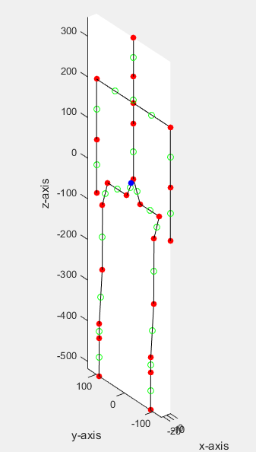

**Inverse Kinematics**

C:\Users\asuss\AppData\Local\Microsoft\Windows\INetCache\Content.Word\Screenshot (346).png

For Inverse Kinematics Equation First Jacobian and then its inverse has been found out. Jacobian has been written in the World Frame.

Pseudo inverse technique has been used to the Inverse of Rectangular Matrix. Pseudo inverse

Limits has been applied to each Link so that Proper Structure of Humanoid is maintained. This Inverse Kinematics is also solved separately for Each Serial Link Chain.

*While Solving Inverse through it is difficult to visualize and control which solution we are going to Obtain. For effectively controlling the solution several constraints are added such as limit and solution of Inverse Jacobian is also checked.

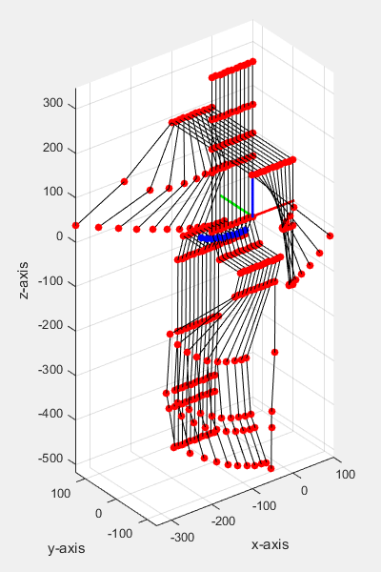

**Walking Posture of Humanoid**

**STATIC FORCE CALCULATION IN 3-LINK PLANAR MANIPULATOR**

5

The above given equation has been used to find the torque at each joint of the manipulator when the end effector force is provided. Where J is the Jacobian matrix.

REF: Introduction to Robotics, 3e - John J Craig

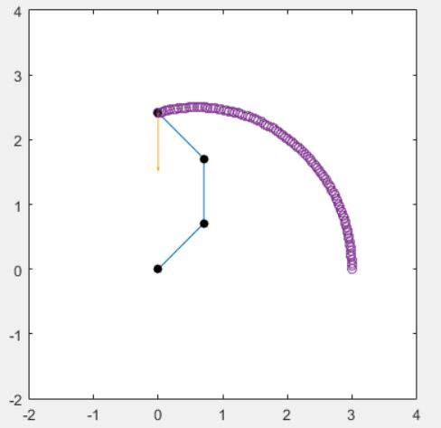

**The snapshot of simulation of 3-link planar manipulator the force acting on it**

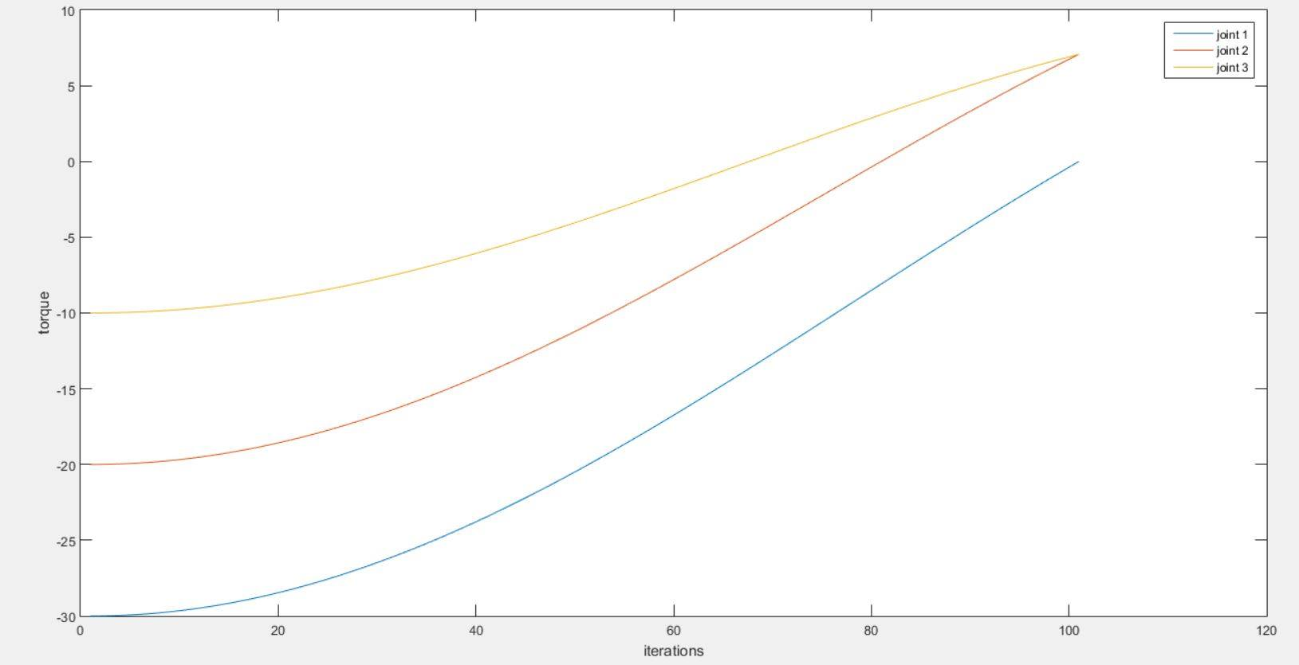

**The graph is plotted with each joint torques and the number of iteration which denotes the position manipulator at that given instance.**

**Rate of change of angular momentum for the humanoid**

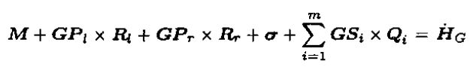

The above given equation is used for calculation of rate of angular momentum about COM (here G).

REF : Rate of change of angular momentum and balance maintenance of biped robots , Ambarish Goswami

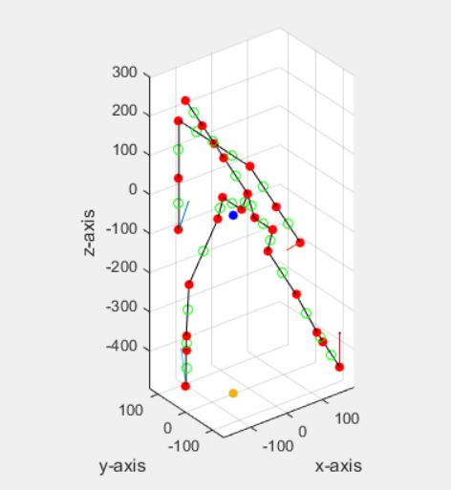

**The above picture shows the position of humanoid at a given instance and the respective forces acting on hands and reaction forces on legs are also displayed, The blue mark in the picture represents the COM of whole humanoid and the yellow mark represents the projected COM on the XY plane.**

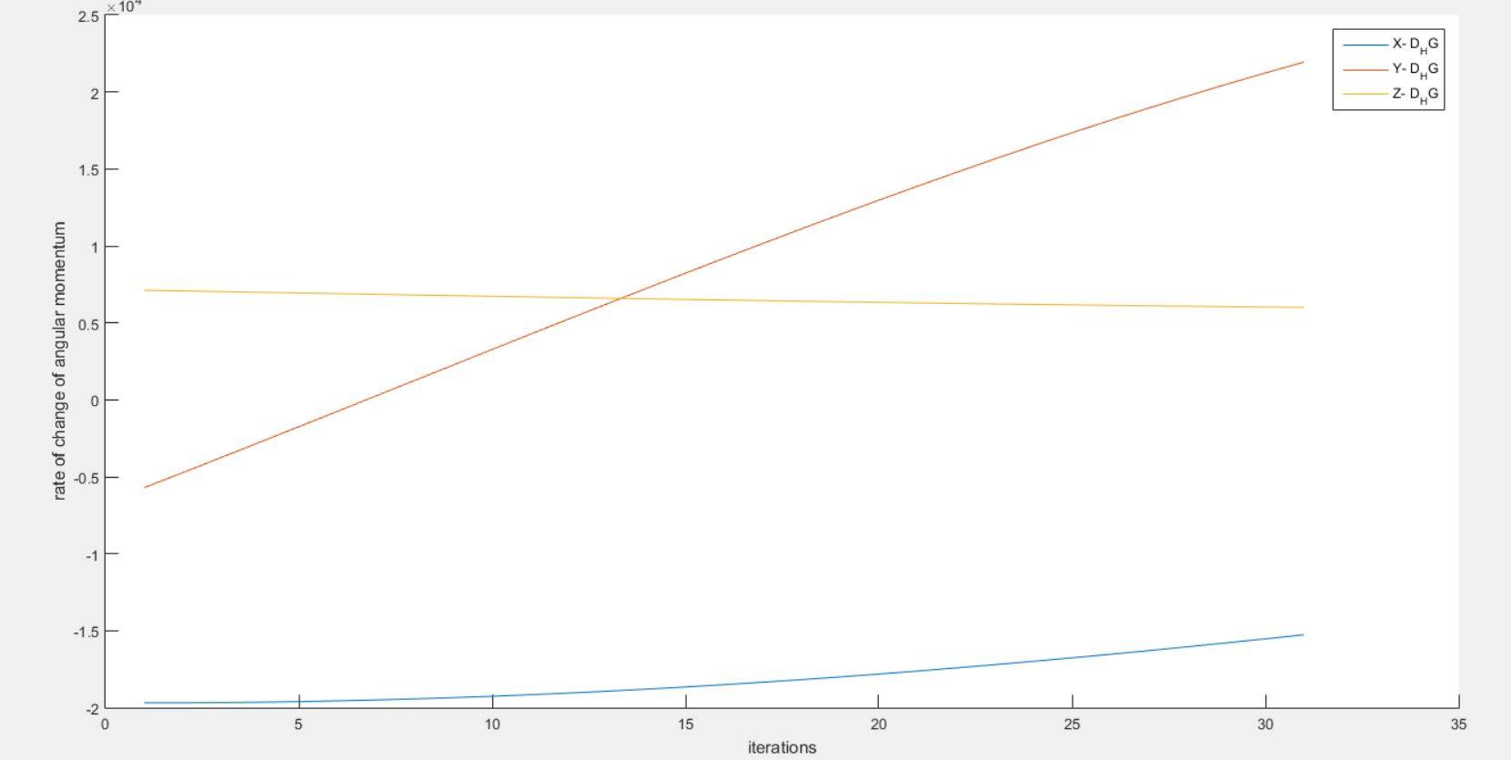

**The plot represents the X, Y, Z rate of angular momentum respectively .The simulation video is also made**